**TSIS ERD**

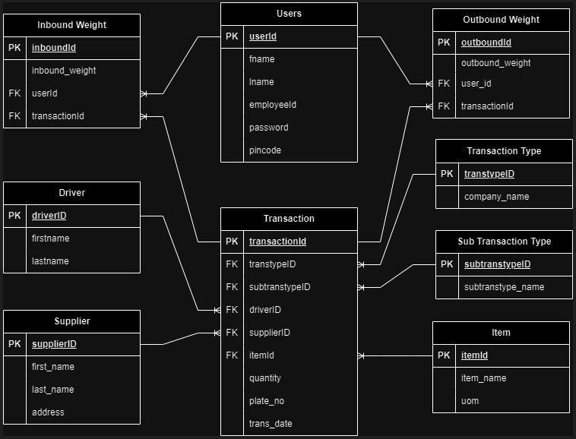

**Normalization**

The ERD above is in third normal form (3NF), which means there are no transitive functional dependencies or partial functional dependencies in the ERD. This means that all of the non-key attributes are fully functionally dependent on the primary key, and that there are no redundant relationships between the entities

* The Transaction entity has a primary key of transactionId.

The transtypeID, subtranstypeID, driverID, supplierID, itemId, trans_date, and quantity attributes are fully functionally dependent on the transactionID, meaning that they cannot exist without a transactionId

* The Transaction Type entity has a primary key of transtypeID.

The company_name attribute is fully functionally dependent on the transtypeID.

* The Sub Transaction Type entity has a primary key of subtranstypeID.

The subtranstype_name attribute is fully functionally dependent on the subtranstypeID.

* The Inbound Weight entity has a primary key of inboundId.

The  userId, transactionID, and inbound_weight attributes are fully functionally dependent on the inboundId.

* The Outbound Weight entity has a primary key of outboundId.

The  userId, transactionID, and inbound_weight, attributes are fully functionally dependent on the outboundId.

* The Users entity has a primary key of userId.

The fname, lname, employeeId, password and pincode attributes are fully functionally dependent on the userId.

* The Driver entity has a primary key of driverID.

The firstname and lastname attributes are fully functionally dependent on the driverID.

* The Supplier entity has a primary key of supplierID.

The first_name, last_name, and address attributes are fully functionally dependent on the supplierID.

* The Item entity has a primary key of itemId.

The item_name and uom, attributes are fully functionally dependent on the itemId.

**Indexing**

Indexes are special lookup tables that need to be used by the database search engine to speed up data retrieval. An index is simply a reference to data in a table.

* **Transaction**
* **Transaction Type**
* **Sub Transaction Type**
* **Inbound Weight**
* **Outbound Weight**
* **Users**
* **Driver**
* **Supplier**
* **Item**

**Attributes**

|  |  |  |
| --- | --- | --- |
| **Transaction** | **Transaction Type** | **Sub Transaction Type** |
| * transactionId (PK) * transatypeID (FK) * subtranstypeID (FK) * driverID (FK) * supplierID (FK) * itemId (FK) * quantity * trans_date | * transtypeID (PK) * company_name | * subtranstypeID (PK) * subtranstype_name |
| **Inbound Weight** | **Outbound Weight** | **Supplier** |
| * inboundId (PK) * userId (FK) * transactionId (FK) * inbound_weight | * outboundId (PK) * userId (FK) * transactionId (FK) * outbound_weight | * supplierID (PK) * first_name * last_name * address |
| **Users** | **Driver** | **Item** |
| * userId (PK) * fname * lname * employeeId * password * pincode | * driverID (PK) * firstname * lastname | * itemId (PK) * item_name * uom |

**Keys**

A primary key is a unique identifier for each row in a table. A foreign key is a column that references the primary key of another table. This is how relationships between tables are created. Below are the keys found in the ERD above:

• Transaction: transactionId

• Transaction Type: transtypeID

• Sub Transaction Type: subtranstypeID

• Inbound Weight: inboundId

• Outbound Weight: outboundId

• Users: userId

• Driver: driverID

• Supplier: supplierID

* Item: itemId